**Online Diary- Joshua Baker**

**16/10/2020**

This week I was joined by Giancarlo Trinidad and Alyssa Lamb to create another game that we later named “Defuse!” The games premise is that two players will be tasked with attempting to diffuse two bombs by cutting wires. The twist being that only one player can view the board to cut the wires, whilst the other player can only see the instructions required to safely diffuse the bombs. Players will be put under pressure on a time limit, and will have to coordinate themselves in order to safely and quickly diffuse the bombs, especially as any mistakes will come with a penalty on the timer.

The materials that were used were 2 online websites as we could not use any physical material. These websites being a whiteboard website(1), a link to a google doc that contains the manual for the game(2) and an online stopwatch(3).

**The game will follow a series of very simple rules:**

* Before the game begins, players must assign themselves as either the diffuser or the instructor.
* As a diffuser the player must give information to the instructor and cut the instructed wires.
* As an instructor the player must feedback which wire to cut to the diffuser, based on their handbook.
* Players must only communicate audibly.
* The game ends once all correct wires are cut on both bombs or the timer runs out.

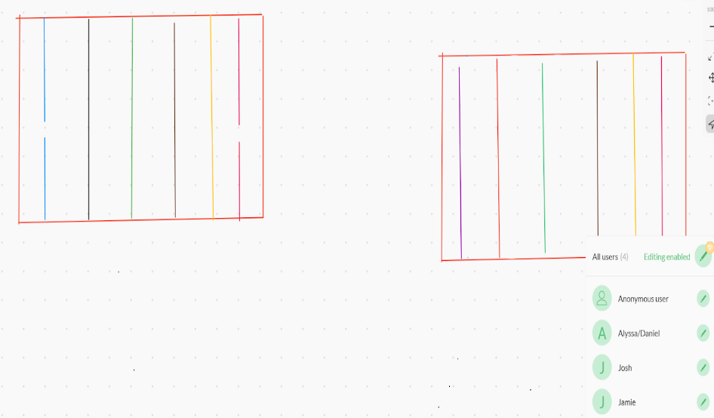How the game is played:

The diffuser will have two bombs as seen and will have to cut the correct coloured wires according to the instructor’s instructions. The instructor will have to read the manual as seen below and carefully read through the manual, communicating with the diffuser to find the correct coloured wire to cut. Therefore diffusing the bomb. This will have to be done twice as there are two bombs.

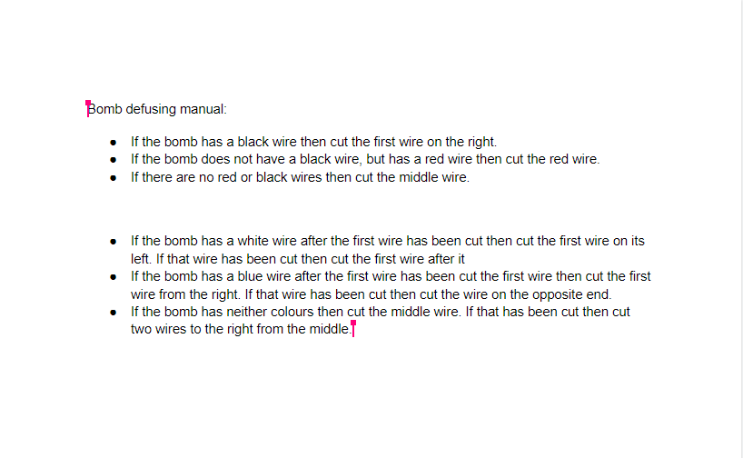Here is the manual as described earlier on. The manual is a series of clues and rules that the instructor will have to carefully read and go through.

Each rule in the manual is very specific to the bombs so both players will need to fully communicate.

Only the instructor is allowed to read the manual.

The manual applies for both bombs not just a single bomb. The instructor will have to guide the diffuser knowing this.

What we found from playtesting as a team is that the bomb was simple to defuse. The play tester also requested that more bombs were available. Play testing only allowed one bomb. Or that more wires were needed to be cut. Not only had this but we found that more variation in coloured wired were needed to make the game a little more complicated. As you can see this did have an impact on the game itself. We implemented 2 bombs and added more wires within the bombs.

I think personally this week working in teams was extremely healthy and good, I felt like for the first time in many weeks that there was no clear problem with our communication, team work and most importantly, our presentation. This is very important to me especially because it was something I kept having problems with in the recent weeks. We labelled our screenshots well and we leaned away from text heavy slides. If there was only one thing that I wish we could have improved is that we could have done more external play testing with more than just 1 outside party, this would give us an even greater idea on what is good about our game and what could be improved.

Hyperlinks:

1. <https://awwapp.com/b/uq9cpvo2czeg6/>
2. <https://docs.google.com/document/d/1PhkgYkGe8SM5RqIo5eGxMsOkBIJttzEFhTpIglpHWZU/edit>
3. <https://www.online-stopwatch.com/timer/5minutes/>